# David’s Ideas on UI

* Each Box represents a screen
* Three different paths based on if you choose “Options” , “How to Play” , or “Start Game”

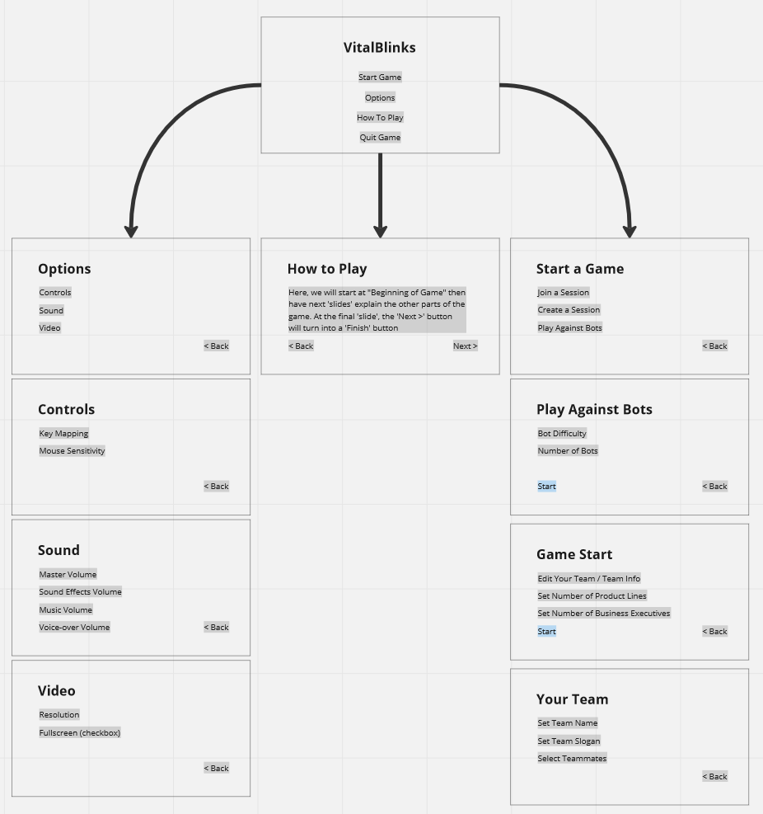

### Main Menu:

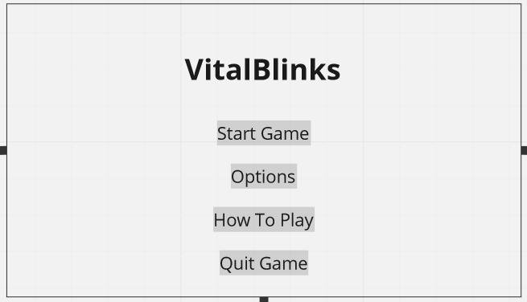

### 

### Start Game Path:

### 

### 

### 

### Options Path:

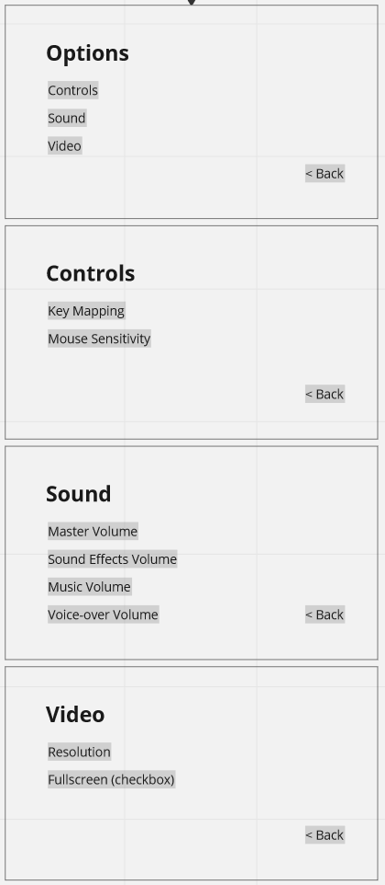

### How-To-Play Path:

